For tips on using PhET sims with your students and for lesson plans written by the PhET team and other teachers, see our [For Teachers](http://phet.colorado.edu/en/for-teachers) page.

**Two & Three Atom Tabs**

In both tabs, you can change the electronegativity of an atom. You may be concerned that students will think this is actually possible; in interviews, no students thought you can change the electronegativity of a *real* atom.

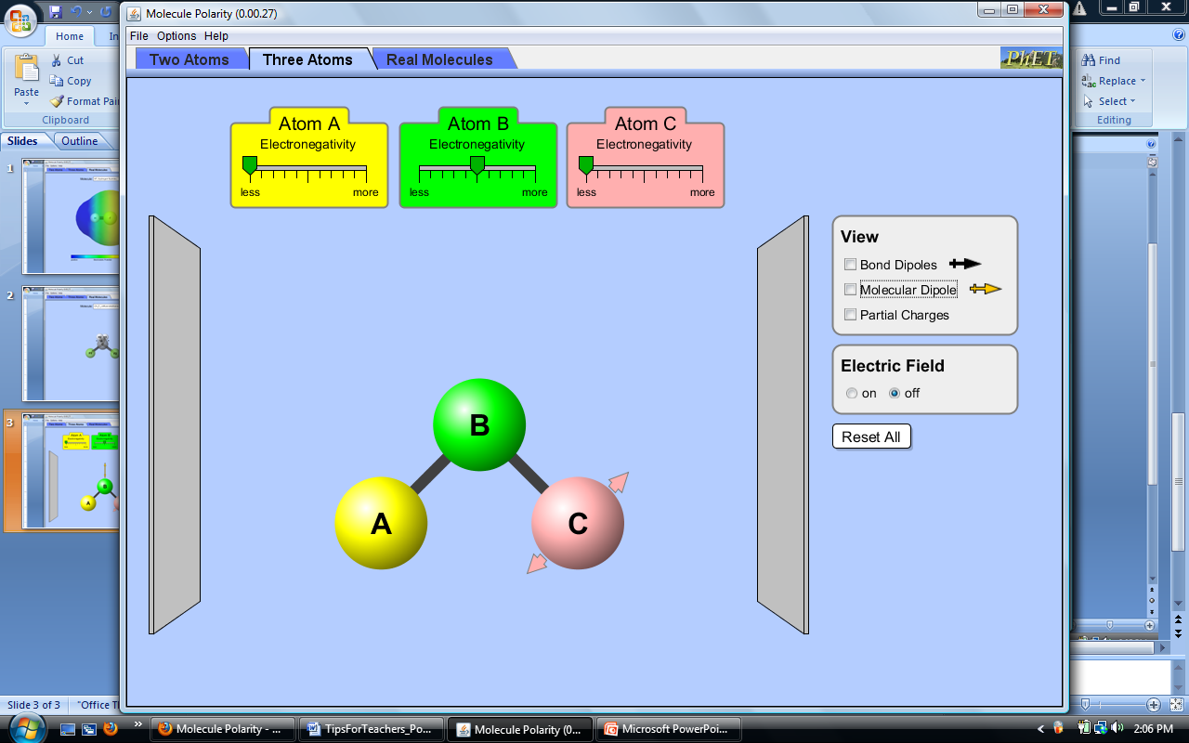Molecule: In both tabs, you can rotate the molecule in 2D. In the 3-atom tab, you can also change the bond angle. In interviews, many students did not find this control before the mouse-over arrows were added. Also note the outer atoms (A and C) do not repel each other; see the Molecule Shapes sim.

View/Surface: The views and surfaces are based on the electronegativity difference set by the slider. In the 3-atom tab, the AB and BC bonds are treated independently; the molecular dipole is the sum of the bond dipoles.

Electric field: In the 2-atom tab, the bond dipole aligns with the field. In the 3-atom tab, the molecular dipole aligns with the field.

**Real Molecules Tab**

In interviews, all students spent the most time on this tab. Some tried to predict the direction of the dipole before using the sim to check, and many went back to the first 2 tabs to make a real molecule.

Molecule/View: You can select a molecule from the drop-down menu and rotate the molecule in 3D. The geometry was optimized in a high-level calculation. The dipoles and surfaces are computed from the partial charges. The molecule is transparent when the dipoles are selected. In CH2F2, the CH bond dipoles are dots because the partial charge difference is small.

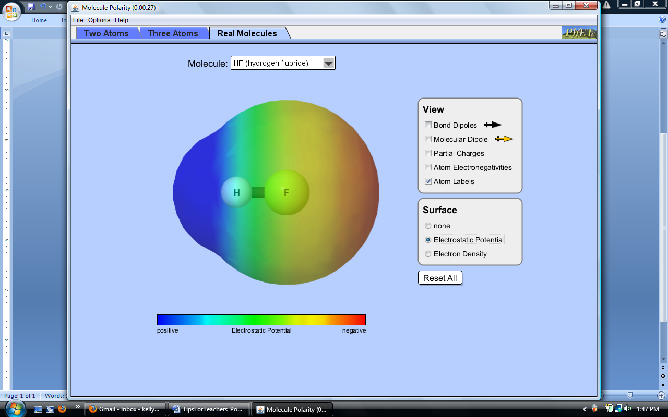Surface: The electrostatic potential and electron density are mapped onto the van der Waals surface for the molecule. In the Options menu, you can select a rainbow color scheme for the electrostatic potential to align with images used in texts.

Exceptions: Because electronegativity does not fully describe molecule polarity, there are some exceptions for real molecules. The most notable is *ozone*: the atoms are the same, but the molecule is polar. Other molecules with partial charges that do not follow the electronegativity trends include: CH2O, CH3F, and CHF3. In interviews, many students notice the exceptions but are not able to explain them using the sim alone.